

|  |
| --- |
| When it comes to finding the perfect venue, every event planner has their own tricks up their sleeve. To help make your search smoother, we’ve gathered five of our favorite hacks for you to use.  These hacks can make venue sourcing faster and easier. Pair them with your own planning strategies, and you’ll be well on your way to finding the perfect spot for your next event.  Got a favorite tool or venue sourcing hack, [**send us an email**](mailto:sayhello@bcdme.com) — we’d love to spotlight it! |



**GOOGLE MY MAPS — Plot And Visualize Venues**

|  |
| --- |
| **URL:** [**https://www.google.co.uk/maps/about/mymaps/**](https://www.google.co.uk/maps/about/mymaps/) |
| **How it helps:** Google My Maps is an excellent tool for anyone looking to plot and visualize multiple venue options in one place. Create custom maps with pins for each venue, nearby hotels, and important landmarks. This visual overview makes it easy to compare venue locations and access logistics like proximity to public transportation. You can also share your map with your team for feedback. |



**TRAVEL TIME CALCULATOR — Evaluate Venue Accessibility**

|  |
| --- |
| **URL:** [**https://app.traveltime.com**](https://app.traveltime.com) |
| **How it helps:** Ever wondered how far your attendees can travel within a certain timeframe? Travel Time has the answer. Whether you're looking for venues that are within a 30-minute drive or accessible by public transport, this tool shows how far people can travel from a specific location in a set time. This makes it easy to narrow down your venue options and ensures your event is within a convenient distance for all attendees. |



**VENUES BY BCD MEETINGS & EVENTS — Simplify Venue Sourcing**

|  |
| --- |
| **Venues by BCD Meetings & Events** |
| **How it helps:** We might be a bit biased, but our Venues by BCD Meetings & Events tool is perfect for anyone who needs to source venues regularly. With access to a huge global database, you’ll find everything you need to know about venues in one place. Whether you want to hand-pick your preferred venues and have us contact them or submit a brief and let our expert sourcing team handle the rest. It will save you time, make the process easier, and get you the perfect venue without the hassle. [**Get in touch**](https://bcdme.com/contact/?mtm_campaign=ultimate-guide-venue-sourcing&mtm_source=lead-magnet&mtm_medium=cta) to learn more. |



**INSTAGRAM TAGGED PHOTOS — Get Authentic Venue Insights**

|  |
| --- |
| **How it helps:** Want to see how a venue looks during an event? The tagging feature on social media platforms like Instagram and TikTok is your best friend. Instead of relying on the venue's official photos, dive into the tagged photos and videos from real attendees. It’s the perfect way to get an unfiltered, behind-the-scenes look at how the space performs during different events. This way, you can check if the venue meets your expectations before you commit. |



**CHECK REVIEWS & ASK FOR RECOMMENDATIONS — Gather Reliable Feedback**

|  |
| --- |
| **How it helps:** Before finalizing your venue choice, it helps to gather as much feedback as possible. There are lots of ways to do this. Checking online reviews, asking friends or colleagues for their experiences, or doing a quick Google search can provide valuable insights into the venue's service quality, amenities, and overall suitability for your event. Reliable feedback from trusted sources will help you make a more informed decision and avoid potential pitfalls. Our team of experts stay up to date with industry press, events, and site visits, ensuring they have the latest insights to share. If you need help, [**get in touch**](https://bcdme.com/contact/?mtm_campaign=ultimate-guide-venue-sourcing&mtm_source=lead-magnet&mtm_medium=cta) to learn more about our sourcing services. |

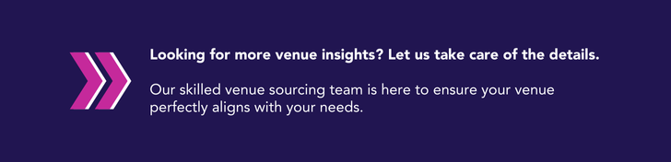

[**Get in touch**](https://bit.ly/4dkDKuQ) to learn more about our venue sourcing services.