

|  |
| --- |
| We all know the importance of a solid brief when searching for the perfect venue— it sets the stage for a successful event by ensuring you’ve covered all the essentials. Filling out this quick template will help you capture all the must-haves, avoid any oversights, and make the venue sourcing process easier.  Simply **copy**, and **fill in**, or **adjust** to meet your unique venue requirements. |

**EVENT DETAILS**

|  |  |
| --- | --- |
| Event name |  |
| Event date |  |
| Event time |  |
| Preferred location |  |
| Event type |  |
| Attendee type |  |
| Number of attendees |  |
| Budget |  |

**KEY REQUIREMENTS**

|  |  |
| --- | --- |
| Number of rooms |  |
| Plenary or general session room |  |
| Syndicate or breakout rooms |  |
| Room capacity |  |
| Layout |  |
| Style/ambiance |  |

**EQUIPMENT REQUIREMENTS**

|  |  |
| --- | --- |
| AV equipment |  |
| Other equipment requirements |  |

**CATERING REQUIREMENTS**

|  |  |
| --- | --- |
| Catering |  |

**ACCOMMODATION** *(if required)*

|  |  |
| --- | --- |
| Number of bedrooms |  |
| Room type |  |
| Check-in/Check-out |  |

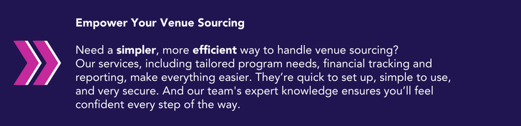

[**Get in touch**](https://bcdme.com/contact/?mtm_campaign=ultimate-guide-venue-sourcing&mtm_source=lead-magnet&mtm_medium=cta) to learn more about our venue sourcing services.