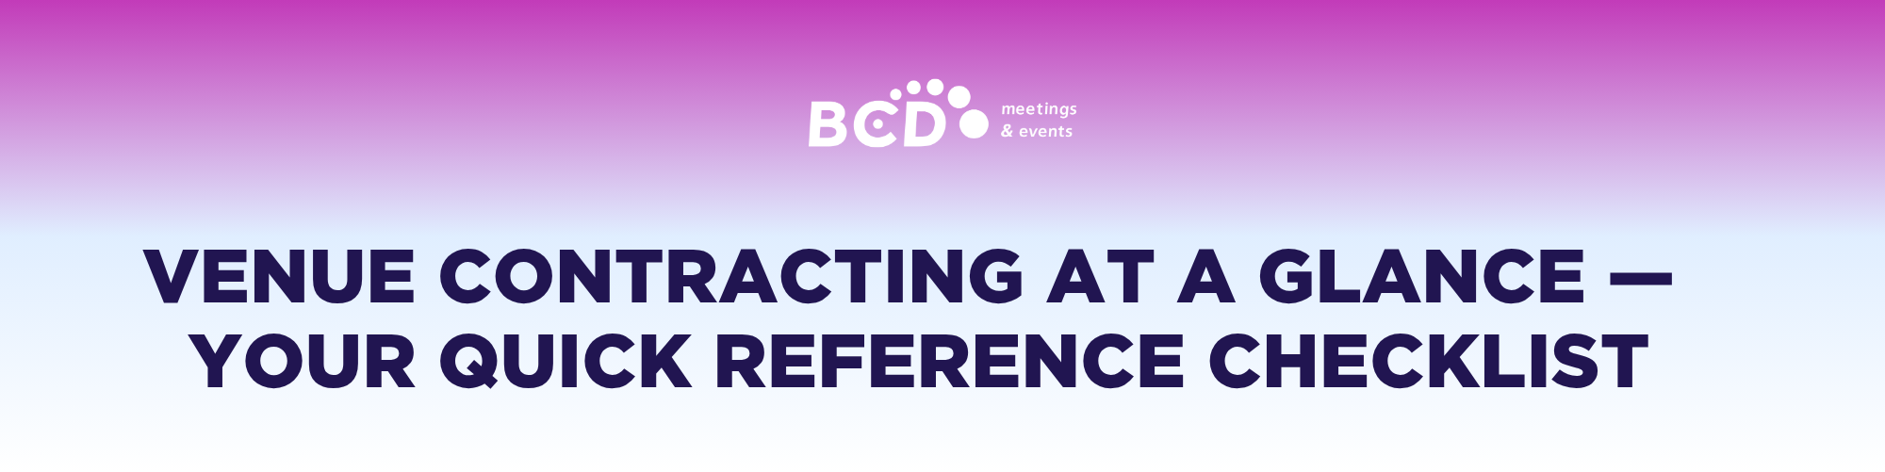

|  |
| --- |
| Perfect venue secured. Now it’s time to focus on the details that will ensure everything runs smoothly. Contracting is a critical step, and while this checklist offers a starting point for key items to review, it’s not an exhaustive guide. That’s where we come in.  Our Venue Sourcing team specializes in managing the complexities of venue contracts, from navigating fine print to minimizing risk. [**Let us handle the rest**](https://bcdme.com/contact/?mtm_campaign=ultimate-guide-venue-sourcing&mtm_source=lead-magnet&mtm_medium=cta). |

|  |  |
| --- | --- |
| o | **DOUBLE CHECK KEY INFORMATION**  We’re sure you’ve checked once but double-check the event date and time in the contract, including setup and teardown periods, is correct. Also, confirm the price, venue name, and address (since some venues have similar names). This will come before force majeure in most contracts. |

|  |  |
| --- | --- |
| o | **REVIEW FORCE MAJEURE CLAUSE**  Take a moment to review the force majeure clause. Make sure it covers everything you need, including cancellation/reselling or rebooking due to unforeseen events. Check the notification procedures are clear. |

|  |  |
| --- | --- |
| o | **CANCELLATION POLICIES AND PAYMENT TERMS**  Confirm the cancellation and reselling policy, including deadlines for refunds or penalties. Clarify payment schedules, including deposits and final payments. |
| o | **LIABILITY AND INSURANCE**  Check liability requirements and clarify responsibilities for damages. Determine if additional insurance is needed. |

|  |  |
| --- | --- |
| o | **SIGNATURE AND DOCUMENTATION**  Ensure all parties sign the contract with the date included. Maintain copies of all signed contracts and amendments for reference. |

**  
  
Why risk mitigation is a crucial step in the venue sourcing journey**

Risk mitigation through proven contracting process is vital because contracts clearly define the responsibilities, expectations, and liabilities of each party. This helps prevent disputes and reduce uncertainty. Here’s why it’s so critical:

* ***Clarity and accountability:*** *Contracts outline scope, deliverables, timelines, and performance standards, reducing the chance of misunderstandings*
* ***Legal protection:*** *A well-drafted contract provides legal recourse if one party fails to meet its obligations.*
* ***Financial safeguards:*** *Risk-shifting mechanisms like attrition, indemnities, warranties, insurance requirements, and limitation of liability clauses protect parties from unforeseen costs.*
* ***Compliance assurance:*** *Contracts can ensure that regulatory, safety, and industry-specific requirements are met, reducing legal and reputational risks.*
* ***Dispute resolution:*** *Including agreed-upon procedures for handling disputes (e.g., arbitration, mediation) helps manage conflicts efficiently.*
* ***Contingency planning:*** *Contracts can plan for force majeure or other disruptions, ensuring business continuity and risk preparedness.*

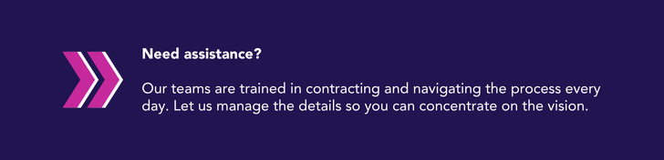

[**Get in touch**](https://bcdme.com/contact/?mtm_campaign=ultimate-guide-venue-sourcing&mtm_source=lead-magnet&mtm_medium=cta) to learn more about our sourcing services.