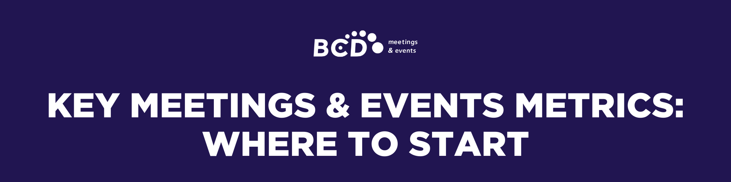

If you don’t currently track meetings and events in a structured way, trying to measure everything at once can feel overwhelming.
The good news is you don’t need complex systems or perfect data to get started. Tracking a small number of high‑level measures can help you understand what’s happening and where there are opportunities to improve.

WHAT TO MEASURE FIRST
Decide what you’re going to track
Before tracking anything, it’s important to agree on what counts as a meeting or
event for your organization. This will vary by company, but the aim is to focus on activity that is meaningful from a cost, risk, or effort perspective.
To keep tracking manageable, many organizations set simple guidelines around size, location, or complexity. For example, this might mean:
- Tracking off‑site meetings above a certain size (such as 10 or more participants)
- Tracking larger on‑site meetings (for example, 25 or more participants)
- Excluding very small or informal meetings.

Once this is defined, start with these measures
Once you’ve agreed on what you are counting as a meeting or event, these are the first measures most organizations begin with. They answer the basic questions people usually ask: How many meetings are taking place, how much they cost and what that means in practice, without needing complex systems or specialist tools.

Metric | What It Tells You | Why it’s Important | How it’s Calculated
Number of Meetings | How many meetings or events take place in a given period | Creates basic visibility and establishes opportunity and scale | Count of meetings held in a defined period
Total Meetings Spend | How much is spent on meetings overall | Reveals the true financial impact of meetings | Total spend for all meetings
Average Cost per Meeting | The typical cost of a meeting | Useful for budgeting and comparing meeting types | Total meetings spend ÷ number of meetings
Average Cost per Attendee | Spend per person attending a meeting | Helps highlight efficiency and value | (Cost per meeting ÷ number of attendees), averaged across meetings
Why these first?
Together, these metrics give you a clear view of meeting volume, overall cost, and relative value. They help you see what’s happening today and provide a reliable base to build on as you look for deeper insight over time.

WHAT TO CAPTURE FOR EACH MEETING
To calculate the metrics above, you need to consistently capture a small set of data for each individual meeting. This doesn’t need to be complex. It just needs to be consistent.
Set up a simple process for collecting this data. Start with one region, ideally where volume or spend is highest, to pilot the approach.
Per-Meeting Data Point | Why You Need It | How It’s Used
Confirmation the meeting took place | Ensures the meeting is counted | Used to calculate the total number of meetings
Unique meeting identifier (name or reference) | Prevents duplicates and gaps | Supports accurate counting and reporting
Meeting date | Allows reporting by month or quarter | Used for time-based reporting and future  lead-time analysis
Location (on‑site or off‑site) | Helps distinguish between different types of meetings | Used to understand patterns, cost drivers, and potential risk
Cost of the meeting | Creates visibility of spend at meeting level | Rolled up to calculate total and average costs
Cost breakdown (venue, F&B, accommodation, AV, other) | Ensures full cost visibility | Added together to calculate total cost per meeting
Number of attendees | Shows scale and efficiency | Used to calculate average cost per attendee
Supplier used (venue, hotel) | Shows where meetings are being sourced | Used to spot patterns, understand supplier usage, and support future supplier strategies

Where to find the information
Many organizations know this information exists somewhere but aren’t always sure where to find it. Rather than waiting for perfect data, starting with what’s available will build momentum and clearer insight will develop over time.
Below are some practical starting points for uncovering meetings and event spend.

 INTERNAL REVIEW
Financial Data
Finance teams are often the best starting point for understanding overall spend.
Useful sources may include:
- Accounts payable records
- Corporate cards or purchasing cards
When reviewing these sources, look for:
- Travel Spend, Meeting Spend, Management Fees
Common suppliers to look for include:
Hotels, Meeting Management Companies, Restaurants, Venues, AV, Production, Ground Transportation, Destination Management Companies
INTERNAL SURVEY
A short internal survey is a practical way to build spend and activity insight, particularly where systems don’t yet exist.
Use the metrics outlined earlier as a guide and start by sending the survey to teams that regularly arrange meetings and events, such as:
- Sales
- Marketing
- HR
- Executive assistants or office teams
EXTERNAL BENCHMARKING
When internal data is limited or incomplete, external benchmarks can provide helpful context as meetings and events spend is often linked to wider travel and business activity. These benchmarks are not designed to replace internal data, but they can support early estimates and help sense‑check assumptions.
Use the following industry benchmarks to estimate overall meeting and event spend:
- 25–35% of total Travel & Expense (T&E) spend
- 35–60% of corporate air volume
- 1–3% of annual revenue
WORK WITH A PARTNER
Another option is to work with a strategic partner, such as BCD Meetings & Events, to help identify and bring together meeting and event spend. Partners that work with this data every day can often uncover essential information more quickly and provide useful benchmarks based on similar organizations.

WHAT BECOMES POSSIBLE
Once you have the basics in place, there is a much wider range of meeting and event data you can choose to track. As this data builds, it can help organizations create efficiencies, reduce risk, and support more confident, informed decision‑making.



