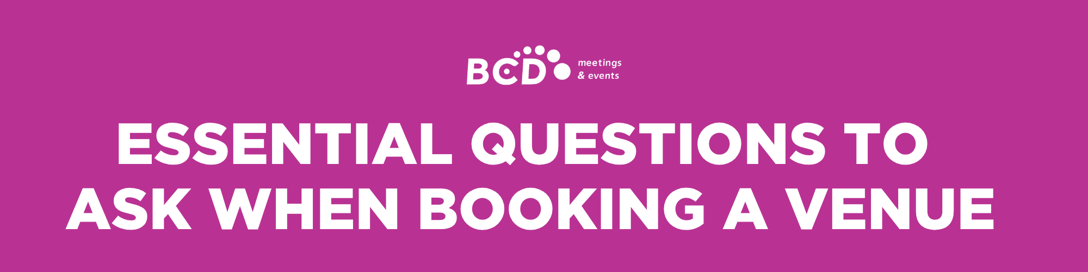

You’ve found a venue that looks perfect for your event—great start! Now it’s time to nail down the specifics to ensure everything meets your needs. Asking the right questions is key to understanding what’s included, any potential extra costs, and how the venue will support your event. Use this list to cover the essentials and understand what the venue provides. This helps avoid surprises an ensure a smooth planning process!

RESERVATION DETAILS
Are you holding the reservation on the first option?
Until when are you holding the first option?
Will the venue require a deposit? What form of payment will you accept?

MEETING ROOM INFORMATION
What is the name(s) of the meeting room(s)?
What is the maximum capacity of the space?
What are the minimum number of delegates requested for the room provided?
Does the space have natural daylight?
On which floor is the space located?
How will guests get from the building entrance to the meeting room? (for example: dedicated meeting floor elevator, escalator, etc.)
Where are the nearest bathrooms/toilets? How large are they?
Is there a room hire charge? If yes, what is it? Does this include service charges and taxes?
Will AV equipment be included?
Can a floor plan and capacity chart be sent over?
Could a photo of the space be sent over?

FOOD AND BEVERAGE MINIMUMS
What is required food & beverage minimum spend?
Is the minimum spend subject to service charge and tax? If so, what are they an is the gratuity taxable?

DAY DELEGATE RATE (DDR)
What is the DDR cost? Does this include taxes?
If yes, what is included in the DDR package?
Do you require minimum numbers? If so, what are they?
Where will tea and coffee be served?
Where will lunch be served?
What type of lunch will be served (buffet, working, etc.)?

PRIVATE DINNER ROOM
What is the name of the private dining room?
Is the room 100% private or semi-private?
Will guests be traveling through the dining room to get to the private dining room or is there a private entrance?
Where are the nearest bathrooms/toilets?
What is the maximum capacity of the room?
What is the room hire, if applicable?
Is there a minimum spend requirement? If so, what is the amount? Does this include taxes?
Where are the nearest bathrooms/toilets? How large are they?
Is there a service charge added to the final bill? If so, how much? Does this include taxes?

FOOD AND BEVERAGE
Please attach food and beverage menus
Do you require a pre-order, and when is it required?
Do you require a minimum spend? Does this include taxes?
Is a service charge added to the final bill? If so, how much? Does this include taxes?
Catering costs — do these include service charges and taxes?
- Three course menu from:
- House wine from:
- Mineral water from:
- Cost of tea and coffee from:
- Canapes from:
- Champagne from:
- Soft drinks from:
- Bottles of beer from:

ACCOMODATION
What is the accommodation rate? Is breakfast included? Does this include taxes?
What is the accommodation rack rate? Does this include taxes?
What room type has been reserved?
Do the room types vary across the room block?

ADDITIONAL INFORMATION
Please provide your cancellation, resale and/or rebbooking terms
Please provide your payment terms
Is Wi-Fi included in guest room rate?
Is Wi-Fi included in meeting room rental?
Do you have car parking? What is the daily/hourly costs? Is valet required?
Are there any competitors of [insert company name] on site, such as x, y or z?



